BÁO CÁO THỰC HÀNH
IT3280 – 147793 – THỰC HÀNH KIẾN TRÚC MÁY TÍNH
Tuần 07: PROCEDURE CALLS, STACK AND POINTER
Họ và tên | Lê Đồng Cảnh Phú
Mã số sinh viên | 20225755

Assignment 1
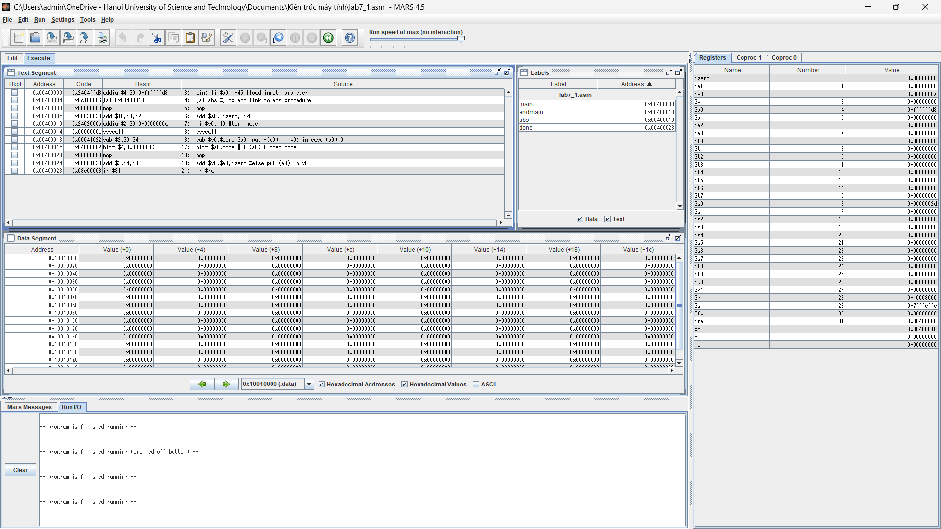
#Laboratory Exercise 7 Home Assignment 1
.text
main: li $a0, -45 #load input parameter
jal abs #jump and link to abs procedure
nop
add $s0, $zero, $v0
li $v0, 10 #terminate
syscall
endmain:
#--------------------------------------------------------------------
# function abs
# param[in] $a0 the interger need to be gained the absolute value
# return $v0 absolute value
#--------------------------------------------------------------------
abs:
sub $v0,$zero,$a0 #put -(a0) in v0; in case (a0)<0
bltz $a0,done #if (a0)<0 then done
nop
add $v0,$a0,$zero #else put (a0) in v0
done:
jr $ra
Trạng thái chạy
Trạng thái chạy | $a0 | $v0 | $s0 | $ra | $pc
Ban đầu | 0x00000000 | 0x00000000 | 0x00000000 | 0x00000000 | 0x00400000
Chạy lệnh li $a0 | 0xffffffd3 | 0x00000000 | 0x00000000 | 0x00000000 | 0x00400004
Chạy lệnh jal | 0xffffffd3 | 0x0000002d | 0x00000000 | 0x00400008 | 0x00400018
Chạy lệnh sub | 0xffffffd3 | 0x0000002d | 0x00000000 | 0x00400008 | 0x0040001c
Chạy lệnh bltz | 0xffffffd3 | 0x0000002d | 0x00000000 | 0x00400008 | 0x00400028
Chạy lệnh jr $ra | 0xffffffd3 | 0x0000002d | 0x00000000 | 0x00400008 | 0x00400008
Chạy lệnh add $s0 | 0xffffffd3 | 0x0000002d | 0x0000002d | 0x00400008 | 0x0040000c
Chạy lệnh syscall | 0xffffffd3 | 0x0000000a | 0x0000002d | 0x00400008 | 0x00400018

Chương trình chạy đến lệnh jal sẽ nhảy đến abs và thực hiện các lệnh . Khi đó $v0 sẽ lưu giá trị tuyệt đối của $a0. Sau đó chương trình lưu phần giá trị của $v0 vào $s0 và kết thúc chương trình

Assignment 2
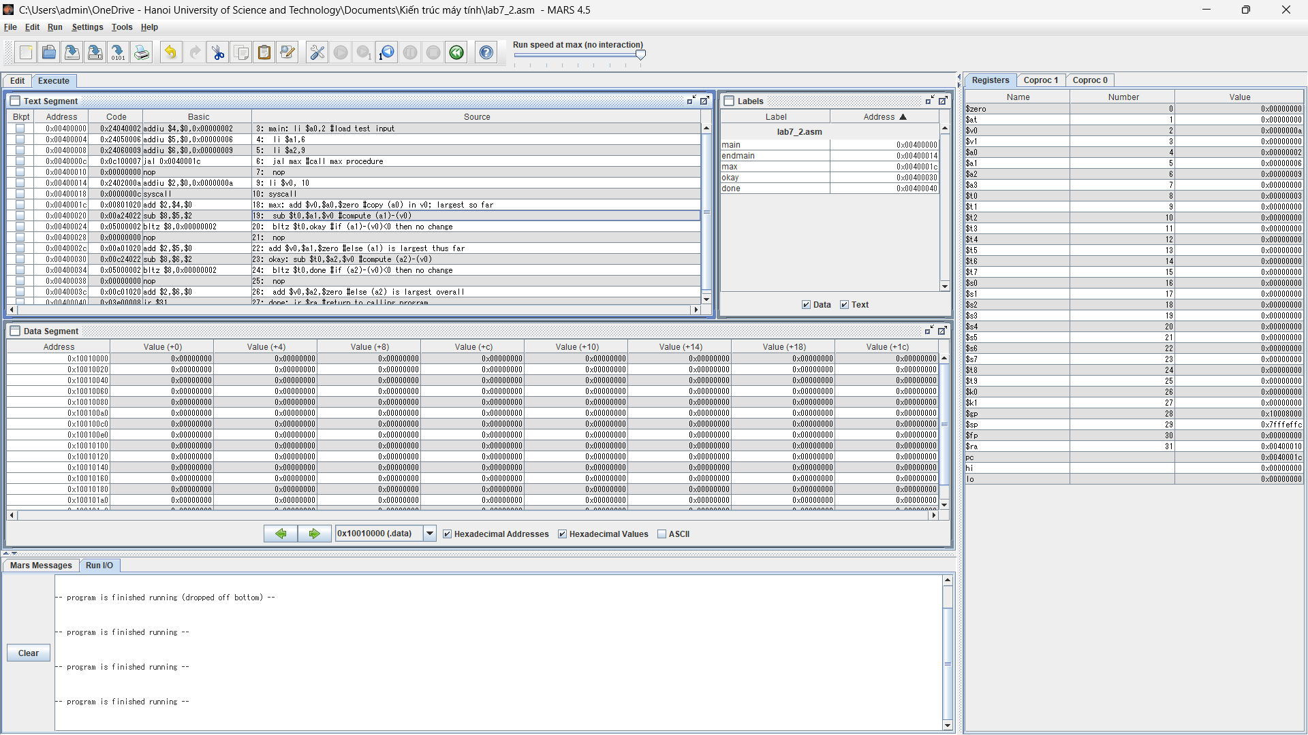
#Laboratory Exercise 7, Home Assignment 2
.text
main: li $a0,2 #load test input
li $a1,6
li $a2,9
jal max #call max procedure
nop
endmain:
li $v0, 10
syscall
#---------------------------------------------------------------------
#Procedure max: find the largest of three integers
#param[in] $a0 integers
#param[in] $a1 integers
#param[in] $a2 integers
#return $v0 the largest value
#---------------------------------------------------------------------
max: add $v0,$a0,$zero #copy (a0) in v0; largest so far
sub $t0,$a1,$v0 #compute (a1)-(v0)
bltz $t0,okay #if (a1)-(v0)<0 then no change
nop
add $v0,$a1,$zero #else (a1) is largest thus far
okay: sub $t0,$a2,$v0 #compute (a2)-(v0)
bltz $t0,done #if (a2)-(v0)<0 then no change
nop
add $v0,$a2,$zero #else (a2) is largest overall
done: jr $ra #return to calling program
Chương trình so sánh giá trị trong 3 thanh ghi $a0,$a1,$a2. $v0 là thanh ghi lưu giá trị lớn nhất
Đầu tiên lấy $v0=$a0
Lấy a1-v0 nếu bé hơn 0 thì gán v0=a1
Tiếp tục a2-v0 nếu bé hơn 0 thì gán v0=a2

Assignment 3
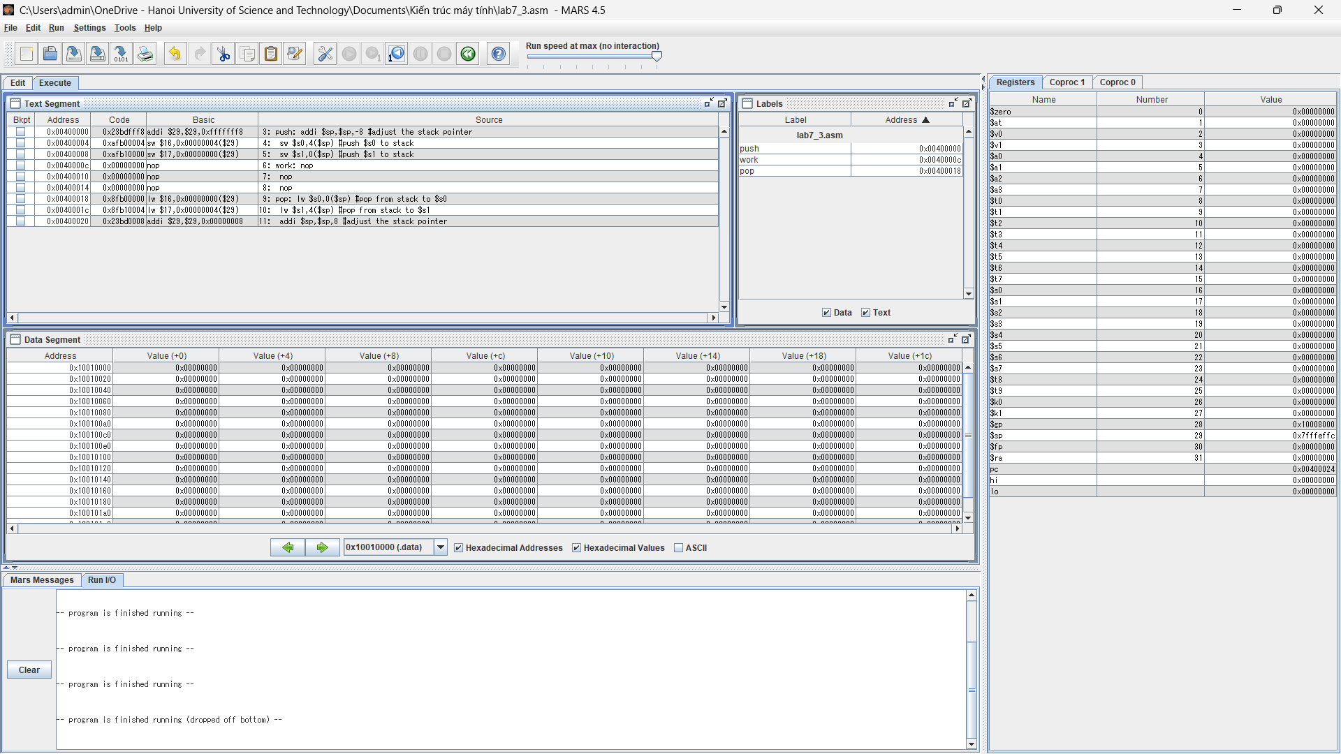
#Laboratory Exercise 7, Home Assignment 3
.text
push: addi $sp,$sp,-8 #adjust the stack pointer
sw $s0,4($sp) #push $s0 to stack
sw $s1,0($sp) #push $s1 to stack
work: nop
nop
nop
pop: lw $s0,0($sp) #pop from stack to $s0
lw $s1,4($sp) #pop from stack to $s1
addi $sp,$sp,8 #adjust the stack pointer

Assignment 4
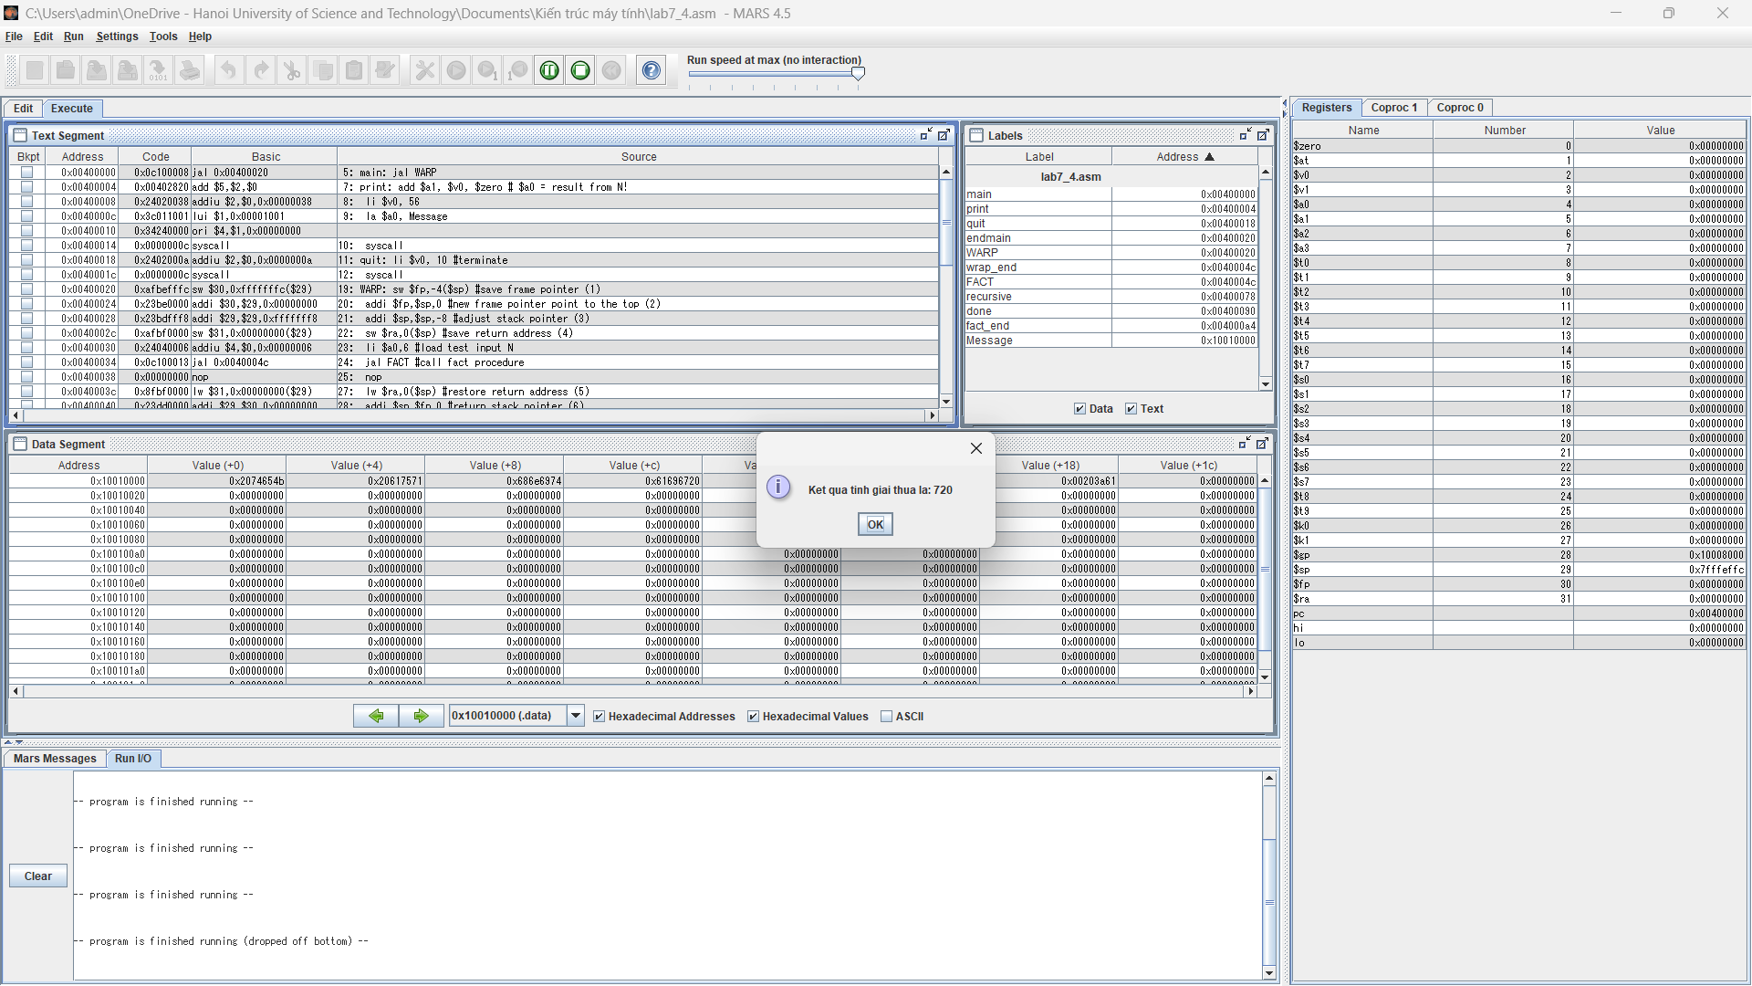
#Laboratory Exercise 7, Home Assignment 4
.data
Message: .asciiz "Ket qua tinh giai thua la: "
.text
main: jal WARP

print: add $a1, $v0, $zero # $a0 = result from N!
li $v0, 56
la $a0, Message
syscall
quit: li $v0, 10 #terminate
syscall
endmain:
#---------------------------------------------------------------------

#Procedure WARP: assign value and call FACT
#---------------------------------------------------------------------

WARP: sw $fp,-4($sp) #save frame pointer (1)
addi $fp,$sp,0 #new frame pointer point to the top (2)
addi $sp,$sp,-8 #adjust stack pointer (3)
sw $ra,0($sp) #save return address (4)
li $a0,6 #load test input N
jal FACT #call fact procedure
nop

lw $ra,0($sp) #restore return address (5)
addi $sp,$fp,0 #return stack pointer (6)
lw $fp,-4($sp) #return frame pointer (7)
jr $ra
wrap_end:
#---------------------------------------------------------------------

#Procedure FACT: compute N!
#param[in] $a0 integer N
#return $v0 the largest value
#---------------------------------------------------------------------

FACT: sw $fp,-4($sp) #save frame pointer
addi $fp,$sp,0 #new frame pointer point to stack’s top
addi $sp,$sp,-12 #allocate space for $fp,$ra,$a0 in stack
sw $ra,4($sp) #save return address
sw $a0,0($sp) #save $a0 register

slti $t0,$a0,2 #if input argument N < 2
beq $t0,$zero,recursive#if it is false ((a0 = N) >=2)
nop
li $v0,1 #return the result N!=1
j done
nop
recursive:
addi $a0,$a0,-1 #adjust input argument
jal FACT #recursive call
nop
lw $v1,0($sp) #load a0
mult $v1,$v0 #compute the result
mflo $v0
done: lw $ra,4($sp) #restore return address
lw $a0,0($sp) #restore a0
addi $sp,$fp,0 #restore stack pointer
lw $fp,-4($sp) #restore frame pointer
jr $ra #jump to calling
fact_end:

Assignment 5
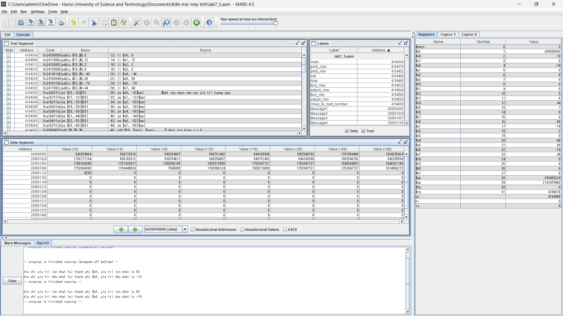
.data
Message1: .asciiz "dia chi gia tri lon nhat tai thanh ghi $s"

Message2: .asciiz ", gia tri lon nhat la "

Message3: .asciiz "\ndia chi gia tri nho nhat tai thanh ghi $s"

Message4: .asciiz ", gia tri nho nhat la "

.text

li $s0, 9

li $s1, 12

li $s2, 2

li $s3, 0

li $s4, -48

li $s5, 68

li $s6, -74

li $s7, 44

main:

sw $s0, -4($sp) #dat vao ngan xep cac gia tri tuong ung

sw $s1, -12($sp)

sw $s2, -20($sp)

sw $s3, -28($sp)

sw $s4, -36($sp)

sw $s5, -44($sp)

sw $s6, -52($sp)

sw $s7, -60($sp)

add $t0, $zero, $zero # khoi tao bien i = 0

jal loop

print_max:

li $v0, 4

la $a0, Message1

syscall

li $v0, 1

add $a0, $t2,$zero

syscall

li $v0, 4

la $a0, Message2

syscall

li $v0, 1

add $a0, $s0, $zero

syscall

print_min:

li $v0, 4

la $a0, Message3

syscall

li $v0, 1

add $a0, $t3, $zero

syscall

li $v0, 4

la $a0, Message4

syscall

li $v0, 1

add $a0, $s1, $zero

syscall

exit:

li $v0, 10

syscall

loop:

sw $t0, 0($sp)

addi $t0, $t0, 1 # tang bien don vi i = i + 1

slti $t1, $t0, 8

bne $t1, $zero, move_to_next_number

lw $s0, -4($sp)

lw $t2, 0($sp) #vi tri

find_max:

lw $t3, 4($sp) #phan tu ke tiep sau max

lw $t4, 8($sp) #vi tri cua phan tu do

slt $t1, $t3, $s0 #so sanh the tim max

bne $t1, $zero, adjust_max

add $s0, $t3, $zero

add $t2, $t4, $zero

adjust_max:

addi $sp,$sp,8 # di chuyen con tro stack

bgtz $t4, find_max # Neu i > 0 thi loop

lw $s1,-4($sp) # khoi tao max ban dau

lw $t3,0($sp)

find_min:

lw $t5, -8($sp)

lw $t4,-12($sp)

slt $t1, $s1, $t4

bne $t1, $zero, adjust_min

add $s1, $t4, $zero

add $t3, $t5, $zero

adjust_min:

addi $sp, $sp, -8

slti $t1, $t5, 7

bne $t1, $zero, find_min

jr $ra

move_to_next_number:

addi $sp, $sp, -8

j loop

